**Lab Report**

Title: Suitability Analysis

Notice: Dr. Bryan Runck

Author: Michael Felzan, Cole Anderson

Date: 2/18/21

**Project Repository:** *<weblink to public repository>*

**Abstract**

*<Delete this text in light grey throughout>*

*250 words max. Clearly summarize the following major sections. Each gets one or two sentences.*

**Problem Statement**

Do a GIS suitability analysis to find possible home locations within 10 miles from Chaska and greater that 1000 ft. from any rivers.

*Table 1. <insert caption>*

|  |  |  |  |  |  |  |
| --- | --- | --- | --- | --- | --- | --- |
| **#** | **Requirement** | **Defined As** | **Spatial Data** | **Attribute Data** | **Dataset** | **Preparation** |
| 1 | Distance from rivers | >1000 ft | Rivers |  | <https://gisdata.mn.gov/dataset/us-mn-state-metc-water-lakes-rivers> | Def query to rivers only |
| 2 | Distance from Chaska | < 10 miles | Chaska location |  | <https://gisdata.mn.gov/dataset/loc-pop-centers> | Def Query to Chaska only |
| 3 |  |  |  |  |  |  |
| 4 |  |  |  |  |  |  |

**Input Data**

*Describe the data in two paragraphs max. Fill out the table.*

*Table 2. <insert caption>*

|  |  |  |  |
| --- | --- | --- | --- |
| **#** | **Title** | **Purpose in Analysis** | **Link to Source** |
| 1 | City and Township Population Centers, MN | Establishing buffer around Chaska | <https://gisdata.mn.gov/dataset/loc-pop-centers> |
| 2 | Lakes and Rivers - Open Water Features | Establishing buffer around river polygons | <https://gisdata.mn.gov/dataset/us-mn-state-metc-water-lakes-rivers> |
| 3 |  |  |  |
|  |  |  |  |

**Methods**

Define city centers layer to ‘Chaska’

Define water bodies to “River”

Create 10 mile buffer around point Chaska

Create 1000 ft buffer around all remaining water bodies

Erase river buffer from Chaska buffer

**Results**

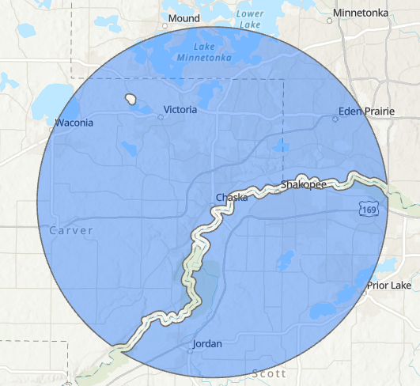

**Results Verification**

Checked distance from river polygon to buffer edge as equal to 1000 feet

Checked distance from city center to buffer edge as equal to 10 miles

**Discussion and Conclusion**

Used Boolean workflow to create proper suitable area for home according to defined criteria

**References**

*Use a common format*

https://gisdata.mn.gov/

**Self-score**

*Fill out this rubric for yourself and include it in your lab report. The same rubric will be used to generate a grade in proportion to the points assigned in the syllabus to the assignment.*

|  |  |  |  |
| --- | --- | --- | --- |
| **Category** | **Description** | **Points Possible** | **Score** |
| **Structural Elements** | All elements of a lab report are included **(2 points each)**:  Title, Notice: Dr. Bryan Runck, Author, Project Repository, Date, Abstract, Problem Statement, Input Data w/ tables, Methods w/ Data, Flow Diagrams, Results, Results Verification, Discussion and Conclusion, References in common format, Self-score | 28 |  |
| **Clarity of Content** | Each element above is executed at a professional level so that someone can understand the goal, data, methods, results, and their validity and implications in a 5 minute reading at a cursory-level, and in a 30 minute meeting at a deep level **(12 points)**. There is a clear connection from data to results to discussion and conclusion **(12 points)**. | 24 |  |
| **Reproducibility** | Results are completely reproducible by someone with basic GIS training. There is no ambiguity in data flow or rationale for data operations. Every step is documented and justified. | 28 |  |
| **Verification** | Results are correct in that they have been verified in comparison to some standard. The standard is clearly stated **(10 points)**, the method of comparison is clearly stated **(5 points)**, and the result of verification is clearly stated **(5 points)**. | 20 |  |
|  |  | 100 |  |